

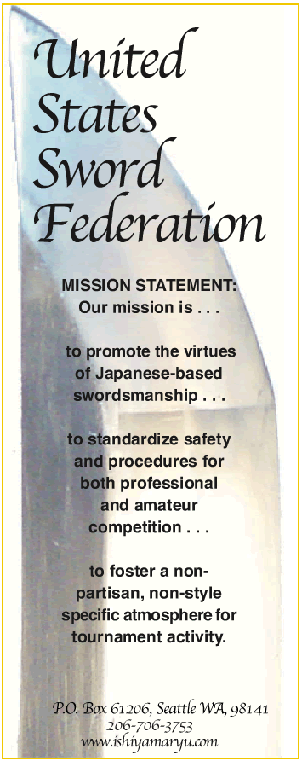


Hello,

We hope you and your classes are doing well.

The United States Sword Federation (USSF) is the only non-partisan tournament sanctioning body for sword competition in the world. Its tournament format is unmatched for its level-playing-field approach.
each member of your school.Contact us to see if your school qualifies.

Each school and student member can receive up to a 20% discount on products and services for all his/her martial arts needs.

Whether you are training just a few students or you have an enrollment of 1,000,the United States Sword Federation is a leader in this great new age of martial arts excellence.
For further information, contact the USSF at (206)706-3753.
The United States Sword Federation welcomes you as a part of this new chapter in martial arts history.

Yours truly,

The Directors, Staff and Members United States Sword Federation


1)Because swordsmanship is the fastest
growing martial art in the world today.
2)Because it is a high-profile,dynamic and
exciting activity that draws enthusiastic
spectators.
3)Because those who cannot compete at a
high level in other martial arts thrive with
sword training.
4)Because everyone has a connection with
the sword. This high-profile activity draws
and generates more interest, traffic,
participants and spectators to your
organization. Contact us today to see how
easy it is to dial up your martial arts scene.
Event Production Staff:
Whether or not you have any experience in this art form, it ’s easier than you think to host your own sword tournament with the assistance of the USSF Event Production Staff. Hosting a sword event means bringing high-profile, responsible sword activity to your community. As host, you invite participants and then enjoy the competition, while we facilitate benchmark, state-of-the-art sword tournament production.
Here is how it works:
By being a host,the Event Production Staff will handle all or part of the following:
1)Promotional requirements (local and
regional advertising).
2)Tournament administration (all entry forms
and procedure for administration).
3)Training of tournament assistants and
personnel (one-hour session with
certification).
4)Training of non-partisan judges (martial
artists know more than you realize
regarding swordsmanship judging and scoring).Its scoring components are no different than other martial arts judging. A one-hour session with video presentation certifies your level one status as a judge or level three ranking as a tournament host--plus the trademarked USSF judges ’ rule book spelling out details of sword tournament activity.

5)Coordination of all sponsorship awards for the top
finishers in each division.

School Name:
_________________________________

Address:
__________________________________________________________________Phone:
_________________________________Fax:
_________________________________
E-Mail:
_________________________________Principal Instructor name, rank, style:
___________________________________________________________________________________________________Sword art(s) taught at your school:
_________________________________What if any, group affiliations do you have in or outside the U.S?
__________________________________________________________________In brief, what is the objective of your training?
__________________________________________________________________Approximately how many participate in your classes?
_________________________________Does your school perform public demonstrations and if so, how many per year?
_________________________________

